SAMPLE PAPER -2013
Class – XII
Subject – Physics
TIME: 3HRS PHYSICS (042) M.M. =70
BLUE PRINT
S.No. | Unit | VSA  (1 mark) | SA I  (2 marks) | SA II  (3 marks) | Value Based Question(4 marks) | LA  (5 marks) | TOTAL
1. | Electrostatics | 1 | 2 | 2 |  | 1 | 16
2. | Current Electricity | 2 | 2 | 1 |  | 1 | 14
3. | Magnetic Effect of Current and Magnetism | 2 | 2 | 2 | 1 |  | 16
4. | Ray Optics | 2 | 1 | 2 |  |  | 10
5. | Electronic Devices | 1 | 1 | 2 |  | 1 | 14
 |  | 8 | 8 | 9 | 1 | 3 | 70

Quarterly Examination (2012-13)
CLASS-XII TIME: 3HRS PHYSICS (042) M.M. =70
BLUE PRINT
S.No. | Unit | VSA  (1 mark) | SA I  (2 marks) | SA II  (3 marks) | Value Based Question(4 marks) | LA  (5 marks) | TOTAL
1. | Electrostatics | 1 | 2 | 2 |  | 1 | 16
2. | Current Electricity | 2 | 2 | 1 |  | 1 | 14
3. | Magnetic Effect of Current and Magnetism | 2 | 2 | 2 | 1 |  | 16
4. | Ray Optics | 2 | 1 | 2 |  |  | 10
5. | Electronic Devices | 1 | 1 | 2 |  | 1 | 14
 |  | 8 | 8 | 9 | 1 | 3 | 70

Quarterly Examination (2012-13) TIME: 3HRS PHYSICS (042) M.M. =70
Q. 1 ABC is an equilateral triangle. Charges +q are placed at each vertex of it. Calculate electric field intensity at O, which is equidistant from all vertices.
A +q

B +q +q C 1
Q. 2 The colour bands of a carbon resistor are in sequence yellow, blue, green and silver respectively. Compute the value of its resistance. 1
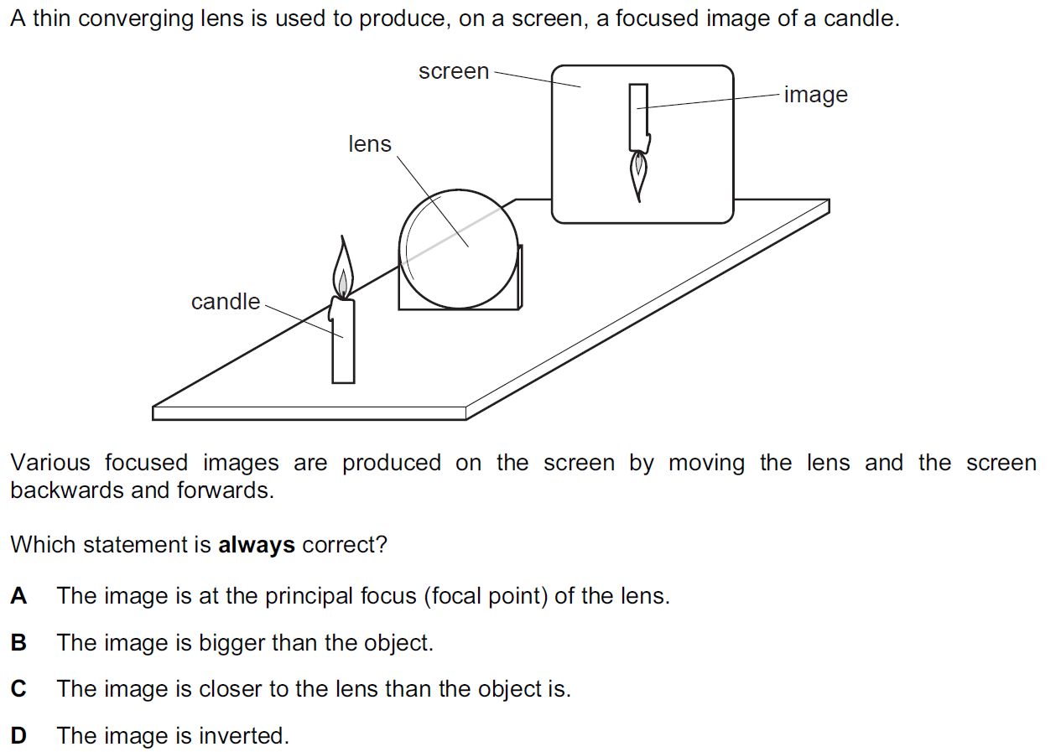
Q. 3

1

Q. 4 It is easy to start a car engine on a warm day than on a cold day, why? 1
Q. 5 What will be the trajectory of a charged particle when it enters in a magnetic field at an angle other than 0⁰, 90⁰ and 180⁰ ? 1
Q. 6 What is the angle of dip at pole of the earth? What will happen to a freely suspended bar magnet at the pole? 1
Q. 7 What is value of linear magnification produced by a plane mirror? Give a condition when a thin lens has a lateral magnification -1. 1
Q. 8 Study the given truth table and name the logic gate which represents it? 1
INPUT |  | OUTPUT
A | B | Y
0 | 0 | 1
0 | 1 | 1
1 | 0 | 1
1 | 1 | 0

Q. 9 What do you mean by equipotential surface? Write any three properties of it? Draw equipotential surface for two charges separated by some distance, when a) Charges are equal in magnitude and have same polarity. b) Charges are equal in magnitude and have different polarity. 2 Q. 10 Explain forward biasing. What will happen if emitter as well as collector in a transistor is forward bias? 2
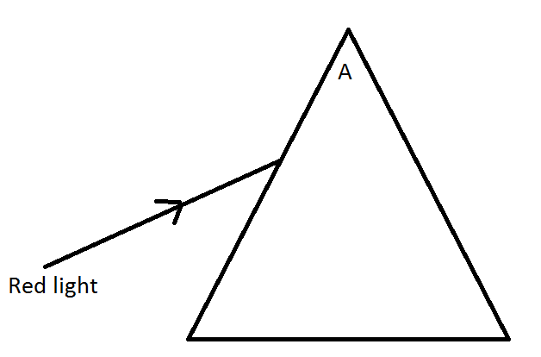
Q. 11 (a) Copy the diagram in your answer script and complete the ray diagram and mark the following

(i) Angle of incidence (ii) Angle of deviation (b) Name the factors on which angle of deviation depend. (c) What will happen if the monochromatic red light is replaced with a white light? 2
Q. 12 What is a capacitor? Write its principle. Derive an expression for common potential attained by two capacitors on sharing. 2
Q. 13 Determine the voltage drop across the resistance R₁ in the circuit given with E = 65 V. R₁ = 50 ohms, R₂ = 100 ohms, R₃ =100 ohms, R₄ = 300 ohms.
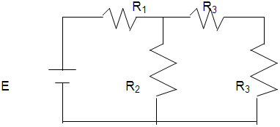
OR
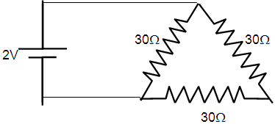
Find the value of current drawn from the cell in the circuit shown.

Q. 14 a) Write two characterstics of a material used for making permanent magnets. b) Why is core of an electromagnet made of ferromagnetic materials? 2
Q. 15a) What happens when a flexible wire carrying a current is placed into a magnetic field?
. 2
Q. 16` A wire of uniform cross section and length l has a resistance of 16 ohms. It is cut into four equal parts. Each part is stretched to length l and all the four stretched parts are connected in parallel. Calculate the total resistance of the combination so formed.
Q. 17 State Gauss’s theorem. Derive Coulomb’s law from Gauss’s theorem.S₁ and S₂ are two parallel concentric spheres enclosing charges ‘Q’ and ‘2Q’ respectively as shown in Fig. Find the ratio of the electric flux through S₁and S₂ . 3 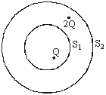
Q. 18 Derive an expression for energy stored in a capacitor. A 4µF capacitor is charged by 200V supply. It is then disconnected from the supply and is connected to another uncharged 2µF capacitor. How much electrostatic energy of the first capacitor is lost in this process of attaining steady situation? 3
Q. 19 a)‘n’ cells each of emf E and internal resistance ‘r’ are connected in series. What is the total emf and internal resistance? b)‘m’ cells each of emf E and internal resistance ‘r’ are connected in parallel. What is the total emf and internal resistance? c) Under what conditions the maximum current is drawn from mixed grouping of cells? 3
Q. 20 Explain elements of earth’s magnetic field. Relate vertical component, horizontal component and angle of dip. 3
Q. 21 Define retentivity and coercivity. Draw hysteresis curve for soft iron not steel. And write the inference for these two. 3
Q. 22 Write the Boolean expression for output for the following circuit. Also write the truth table.
A 3
B Y

Q. 23 Differentiate between conductors, insulators and semiconductors on the basis of energy band diagram. 3
Q. 24 Explain phenomenon of total internal reflection. Write two compulsory conditions for its occurrence. Write any two two incidences where it is applied.
Q. 25 State the relation for angle of deviation , for a prism of small refracting angle. A thin prism of 6⁰ angle gives a deviation of 3⁰ . What is the refractive index of the material of prism?
OR
The refractive index of material of prism of 60⁰ angle for yellow light is √2. Determine following, in case of minimum deviation, i) angle of minimum deviation ii) angle of incidence iii) angle of refraction

Q. 26 Mohan’s uncle, was advised by his doctor to have an MRI scan of his chest. Her uncle did not know much about the details and significance of this test. He also felt that it was too expensive and thought of postponing it.
When Mohan learnt about his uncle’s problems, he immediately decided to do something about it. He took the help of his family, friends and neighbors and arranged for the cost of the test. He also told her uncle that an MRI (Magnetic Resonance Imaging) scan of his test would enable the doctors to know the condition of his heart and lungs without causing any harm to him. This test was expensive because of its set up that needed strong magnetic fields (0.5 T to 3 T) and pulses of radio wave energy.
Her uncle was convinced and had the required MRI scan of his chest done. The resulting information greatly helped his doctors to treat him well.
a)What according to you, are the values displayed by Mohan and his family, friends and neighbors to help his uncle. 2 b) Assuming that the MRI scan of his uncle’s chest was done by using a magnetic field of 1.0 T, find the maximum and minimum values of force that this magnetic field could exert on proton (charge = 1.6 x10⁻¹⁹ C) that was moving with a speed of 10⁴ m/s. State the condition under which the forces has its minimum value. 2
Q. 27 State and explain Kirchhoff’s Law. Derive the condition for obtaining balance in Wheat Stone Bridge. Using the Kirchhoff’s Law in the given circuit, evaluate the values of current I₁, I₂ and I₃.
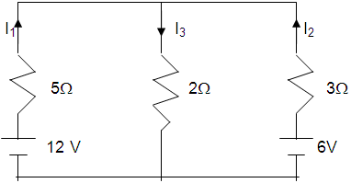 OR State the principle of meter bridge. Why is it named so? Explain its working. A meter bridge wire AB is shown in the figure. Where the free end of the galvanometer should be connected so that deflection in the galvanometer is zero? 5 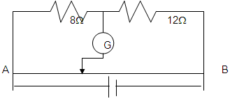
Q. 28 Define the term ‘depletion layer’ and ‘barrier potential’ for a P-N junction diode. How does an increase in doping concentration affect the width of the depletion region? Draw the circuit of a full wave rectifier. Explain its working. OR Explain the working of n-p-n transistor as common emitter amplifier. What is phase difference between input signal and output signal? State any two reason why a common emitter amplifier is preffered to a common base amplifier? 5
Q. 29 Derive an expression for capacitance of parallel plate capacitor . A slab of material of dielectric constant K has same area as the plates of a parallel plate capacitor but has a thickness of ¾d where d is the separation of the plates. How is the capacitance changed when the slab is inserted between the plates?
OR Define electric dipole. Write the condition for its ideal case. Derive an expression for electric field intensity at any point of its axis. How this field intensity is different from that of at equatorial line at the same distance from centre of dipole. 5

Vatsalya Public School, Mandsaur Quarterly Examination (2012-13) CLASS-XII

